
SRM Institute of Science and Technology
Mode of Exam
OFFLINE
College of Engineering and Technology
School of Computing
DEPARTMENT OF COMPUTING TECHNOLOGIES
SRM Nagar, Kattankulathur – 603203, Chengalpattu District, Tamilnadu
Academic Year: 2023-2024 (ODD) Batch 1 – SET A
Test: CLAT-1 Date: 9/8/2023 Course Code & Title:18CSE458T/Wireless and Mobile Communication Duration: 50 Mins
Year & Sem: VII Max. Marks: 25

Course Articulation Matrix:
CO/PO | PO1 | PO2 | PO3 | PO4 | PO5 | PO6 | PO7 | PO8 | PO9 | PO10 | PO11 | PO12 | PSO1 | PSO2 | PSO3
CO1 | 3 | 2 | - | - | - | - | - | - | - | - | - | - | - | - | -
CO2 | 2 | - | - | - | - | - | - | - | - | - | - | - | - | - | -
CO3 | 2 | - | - | - | - | - | - | - | - | - | - | - | - | - | 2
CO4 | 3 | - | 1 | - | - | - | - | - | - | - | - | - | - | - | -
CO5 | 3 | 1 | 2 | - | - | - | - | - | - | - | - | - | - | - | -

Part - A
(5 x 1 = 5 Marks)
Instructions: Answer all
Q. No | Question | Marks | BL | CO | PO | PI Code
1 | Spread spectrum has immunity from  A. Noise  B. Multi-path distortion  C. Noise and Multi-path distortion  D. Amplitude  Ans: C | 1 | 1 | 1 | 1 | 1.6.1
2 | What is the role of transmitter in the communication system?  A. To decode a signal to be transmitted  B. To convert one form of energy into another  C. To detect and amplify information signal from the carrier  D. To produce radio waves to transmit data  Ans: D | 1 | 1 | 1 | 1 | 1.6.1
3 | The original signal of source in modulation is known as  A. Baseband signal  B. Attenuated signal  C. Deviated signal  D. Carrier signal  Ans: A | 1 | 1 | 1 | 1 | 1.6.1
4 | To encode the information in the carrier signal by altering the wave frequency instantaneously is known as  A. Amplitude modulation  B. Frequency modulation  C. Phase modulation  D. Shift keying  Ans: B | 1 | 1 | 1 | 1 | 1.6.1
5 | Digitally encoded signal transmitted with amplitude-modulated signal referred as  A. Frequency shift keying  B. Phase shift keying  C. Amplitude shift keying  D. Phase shift keying  Ans: C | 1 | 1 | 1 | 1 | 1.6.1
Part B
(5 X 2 = 10 Marks)
1 | List any two differences between TCP/IP and OSI Reference model  Ans:  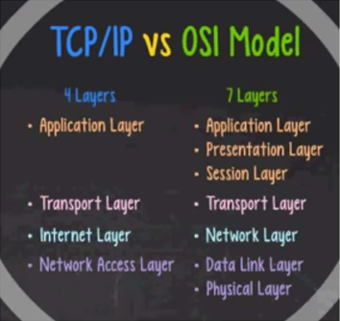 | 2 | 1 | 1 | 1 | 1.6.1
2 | Consider the scenario, John and Bob wants to involve in only Paging and messaging techniques between them using wireless communication. Suggest them what type of communication they can offer? Justify your Answer  Ans:  Transmitters and receivers operate at the same frequency and communication.  It is possible in only one direction from the transmitter to the receiver at any time. | 2 | 2 | 1 | 1 | 1.6.1
3 | Identify the characteristics of a signal with its parameters  Ans:  Signals are the physical representation of data. Users of a communication system can only exchange data through the transmission of signals.  Signals for radio transmission are periodic signals, especially sine waves as carriers | 2 | 1 | 1 | 1 | 1.6.1
4 | Specify the type of multiplexing technique used for traditional television transmitter.  Ans:  FDM technique is used in television transmitter. This technique uses various frequencies to combine streams of data, for sending them on a communication medium, as a single signal. (e.g.) A traditional television transmitter which sends a number of channels through a single cable, uses FDM. | 2 | 1 | 1 | 1 | 1.6.1
5 | Mention any two advantages of double sideband full carrier signal  Ans:  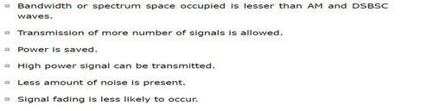 | 2 | 2 | 1 | 1 | 1.6.1
Part – C
( 1 x 10 =10 Marks)
Instructions: Answer any one
6 a.  b. | How several users can share the common channel resource at the same time in Wireless communication? Describe in detail what are the types of possible ways to divide the frequency spectrum among many channels.  Ans:  Multiple Access  Multiplexing  – FDM  – TDM  – CDM  (or)  Illustrate Frequency hopping spread spectrum with necessary diagram.  Ans:  Frequency-hopping spread spectrum (FHSS) transmission is the repeated switching of the carrier frequency during radio transmission to reduce interference and avoid interception.  There are some of the advantages of frequency hopping spread spectrum (FH-SS) given below : It has less distance effect. Provide the greatest amount of spreading. The bandwidth of these systems is large.  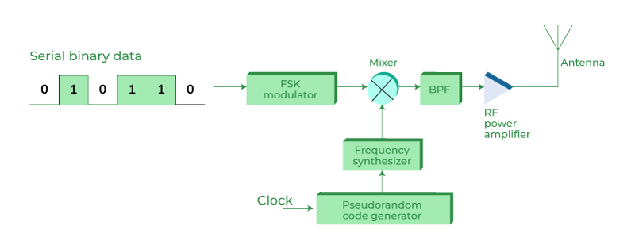 | 10 | 2 | 1 | 1 | 1.6.1

Course Outcome (CO) and Bloom’s level (BL) Coverage in Questions
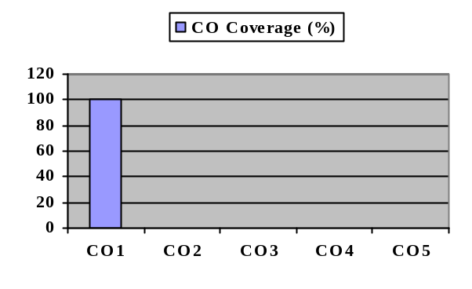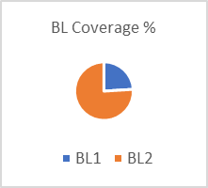

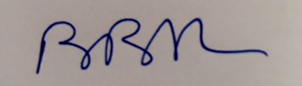

Approved by the Audit Professor/Course Coordinator

